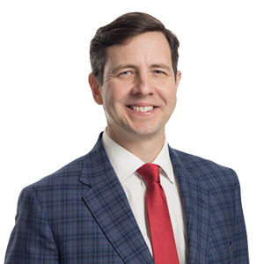 | Doug Butler  Partner  Atlanta, GA, US  t: 404.879.2418  e: douglas.butler@wbd-us.com
Doug Butler is a highly regarded lawyer in the captive insurance industry who has experience in both the management and legal sides of captive insurance. He focuses his practice on insurance regulatory and general corporate transactions, including the formation and management of captive insurance companies, mergers and acquisitions, and corporate governance.
Doug is a board member and former president of the Georgia Captive Insurance Association and an active member of the Cobb and Macon-Bibb Chambers of Commerce and the Macon Civic Club. He grew up in Gainesville, Ga., and received his B.S. in finance from the University of Georgia. He worked in the life insurance industry for five years before earning his J.D. from Mercer Law School.
Representative Experience
Any result the lawyer or law firm may have achieved on behalf of clients in other matters does not necessarily indicate similar results can be obtained for other clients.
- Assisted with the development and operation of captive insurance program for large student loan service provider in US. Captive has grown from a single parent captive to a multi cell facility that is primarily used to reinsure fronted third party risks. Services include negotiate reinsurance and retrocession agreements, draft and revise collateral trust agreements, as well as assist with review of underwriting guidelines. Also serve as regulatory counsel for clients insurance division P&C matters. Estimated premiums in cell facility over next 5 years of excess of $100 million.
- Served as legal counsel to a leading TPA in implementing large F&I captive structure to provide TPA and dealer customers with efficient transfer of risk premium. Premiums in excess of $100mm.
- Formed and implemented multi-line pooling program for captive manager for captive manager’s clients to efficiently cede and assume risk. Premiums in excess of $50mm.
- Serve as legal counsel to form captive for Fortune 100 company to assist with the retention of company risk for general liability, workers compensation. Premiums in excess $200 million.
Professional Engagement
- Georgia Captive Insurance Association, Board Member (President, 2018-2020)
- Captive Insurance Associations in Delaware, Montana, Utah, and Hawaii
- Cobb Chamber of Commerce
- Macon-Bibb Chamber of Commerce
- Macon Civic Club
Education
- J.D., Mercer University School of Law
- B.S., University of Georgia, Finance
Admissions
- Georgia
Related Sectors
Insurance; Insurance – Regulatory and Transactional
Related Services
Corporate; Corporate Governance; Mergers and Acquisitions

