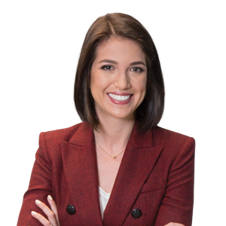 | Lauren F. Anderson  Partner  Raleigh, NC, US  t: 919.755.8127  e: lauren.anderson@wbd-us.com
Lauren F. Anderson's forward-thinking approach to patent prosecution is a refreshing strategy for clients who are seeking assistance in the tech industry. She is in-tune with current trends and advancements, which enables her to identify clients’ patent portfolio needs in an ever-changing market.
From an early age, Lauren’s dream was to be involved in the forefront of innovation. As such, she acquired a bachelor’s degree in mechanical engineering, which has introduced her to a plethora of different technologies that have aided her in preparing and prosecuting a multitude of patent applications thus far. She has experience with preparing and prosecuting both domestic and foreign patents in such sectors as medical devices, aviation systems, aerospace and defense components, smoking and tobacco products, industrial and consumer products, computer hardware, software, telecommunications, computer networking, and imaging technologies.
Not only does Lauren enjoy furthering the goals of her clients, she’s active in furthering the goals of her community as well. She is a member of the firm’s Diversity Committee and chairs a subcommittee focusing on implementing a social media strategy for the Diversity Committee.
Representative Experience
Any result the lawyer or law firm may have achieved on behalf of clients in other matters does not necessarily indicate similar results can be obtained for other clients.
- Prosecutes design patent applications for a leading snack food manufacturer on designs of a variety of snack foods.
- Prepares validity and infringement analyses for global premium kitchen and laundry appliance company.
- Prepares and files US and international patent applications for a leading smoking and tobacco product manufacturer on use of electronic cigarettes and heat-not-burn products.
Professional & Civic Engagement
- Intellectual Property Law Section Newsletter for the North Carolina Bar Association, Co-Editor, 2014 – 2016
- Junior League of Raleigh, Member
- InterAct, Volunteer
- Homeowners' Association (personal), Treasurer
Thought Leadership
- Co-Author, “An Examiner’s Tips For Speedier Patent Prosecution,” IPWatchDog.com, December 19, 2016
Honors & Awards
- Recognized in Best Lawyers: Ones to Watch in America (BL Rankings) in the field of Intellectual Property Law, 2022
Education
J.D., University of New Hampshire School of Law
- Franklin Pierce Intellectual Property Law Certificate
B.S., University of Maryland: Mechanical Engineering
Admitted to Practice
North Carolina
U.S. Patent and Trademark Office
Related Services & Sectors
Services
Intellectual Property, Technology and Data; Patents – Mechanical; Patents – Product Design
Sectors
Manufacturing

